She Drew The Gun announces new album ‘Howl’
to be released 15th November
Submarine Cat Records
2025 album tour dates
Stream previous singles ‘Howl’ and ‘Nothing Lasts’ here
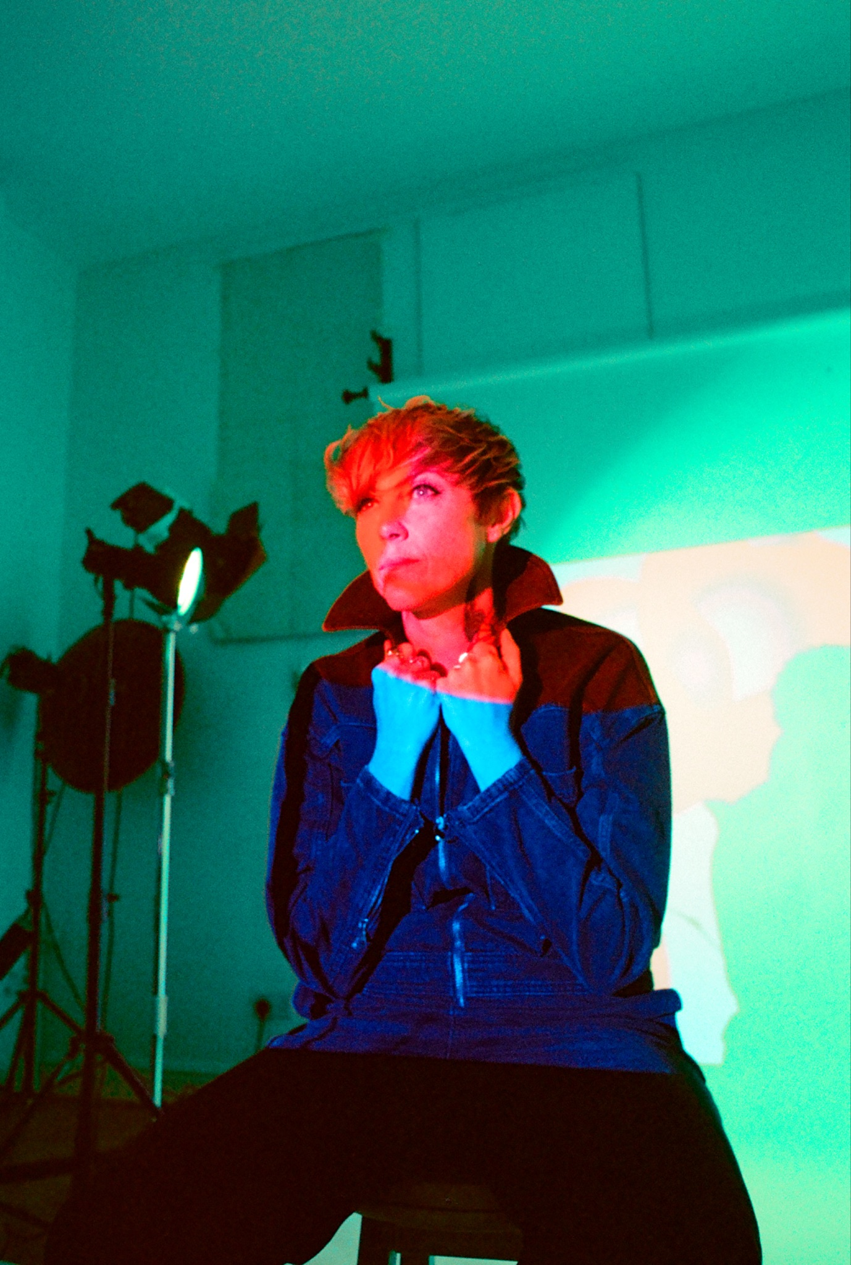
Credit: Rebecca Toohey. Download hi res here

She Drew The Gun has announced her new album ‘Howl’ will be released on Friday 15th November via Submarine Cat Records. Alongside this her album tour dates have been announced for early 2025. Pre-save the album here.

‘Howl’ is the fourth album from She Drew The Gun. It explores a visceral musical world informed by influences ranging from 80's electronica, hip-hop, political poetry, and cosmic scouse psychedelia. Louisa worked on the record with producer Ash Workman (Christine & The Queens, Metronomy) at his studio in Margate. It features recent comeback single ‘Howl’ which was added to the BBC 6 Music playlist.

‘Howl’ is a vivid record, and Louisa talks about the beginnings of the album -

“The album is born of heartache, rock bottoms, morning pages, love, tears, interspace trips, meditation, surreal meetings with past selves, shadow boxing, healing in the mountains of Serra da Estrela, remembering who I am.”

Coming from deep introspection and heartbreak, ‘Howl’ is revelatory, She Drew the Gun’s most personal whilst still addressing the social and political injustices she sees out in the world. The songwriting is more defined as her love of poetry brings another dimension to her lyrics. The record had unique beginnings - after a chance meeting Louisa went to the mountains of Serra de Estrella in Portugal, and dived into the healing process. She came out the other side and poured all she’d learned into ‘Howl’. Split into two sides, the first half addresses themes Louisa has long taken aim at. As she says, “There’s the side of the album which is the gun, the conscious spoken word, the thoughts and words on living in late capitalism, on war, on historical perspective.”.

The second side dives into the personal, as Louisa explains, “There’s the other side of the album which is the heartbreak that I’ve been through, the love songs. I think it’s the thing of trauma being a coin with two sides; it opens up portals for you. The whole album’s got a bit of a magical side to it: witches, spells, the moon, the lovers, the cards being dealt, rituals, mirrors.” These two distinct parts make for her best album to date, lyrically brave and musically inventive from an artist that never stands still.

‘Howl’ tracklisting -

Howl
Mirrors
Became
Shine On
Rise
Washed In Blue
Nothing Lasts
Conjuring
What’s The Matter
Ritual

She Drew The Gun has a handful of festival appearances lined up this summer which precede the Howl album tour dates early next year. All dates are below –

Festival dates -

20th July Tolpuddle Martyrs Festival, Dorset
25th August Future Now Festival, Birkenhead

‘Howl’ album tour dates 2025 -

Fri 14 Feb Hebden Bridge Trades Club
Sat 15 Feb Glasgow Room 2
Sun 16 Feb Galashiels MacArts
Tue 18 Feb Newcastle The Grove
Wed 19 Feb Leeds Brudenell Social Club
Thu 20 Feb Manchester The Factory (FAC251)
Fri 21 Feb London Village Underground
Sat 22 Feb Brighton Club Revenge
Tue 25 Feb Bristol Bristol Beacon (The Lantern)
Wed 26 Feb Bedford Bedford Esquires
Thu 27 Feb Birmingham The Castle & Falcon

Tickets go on sale on Friday 19th July at 10am.

Instagram / Spotify / Apple Music / Twitter / Facebook

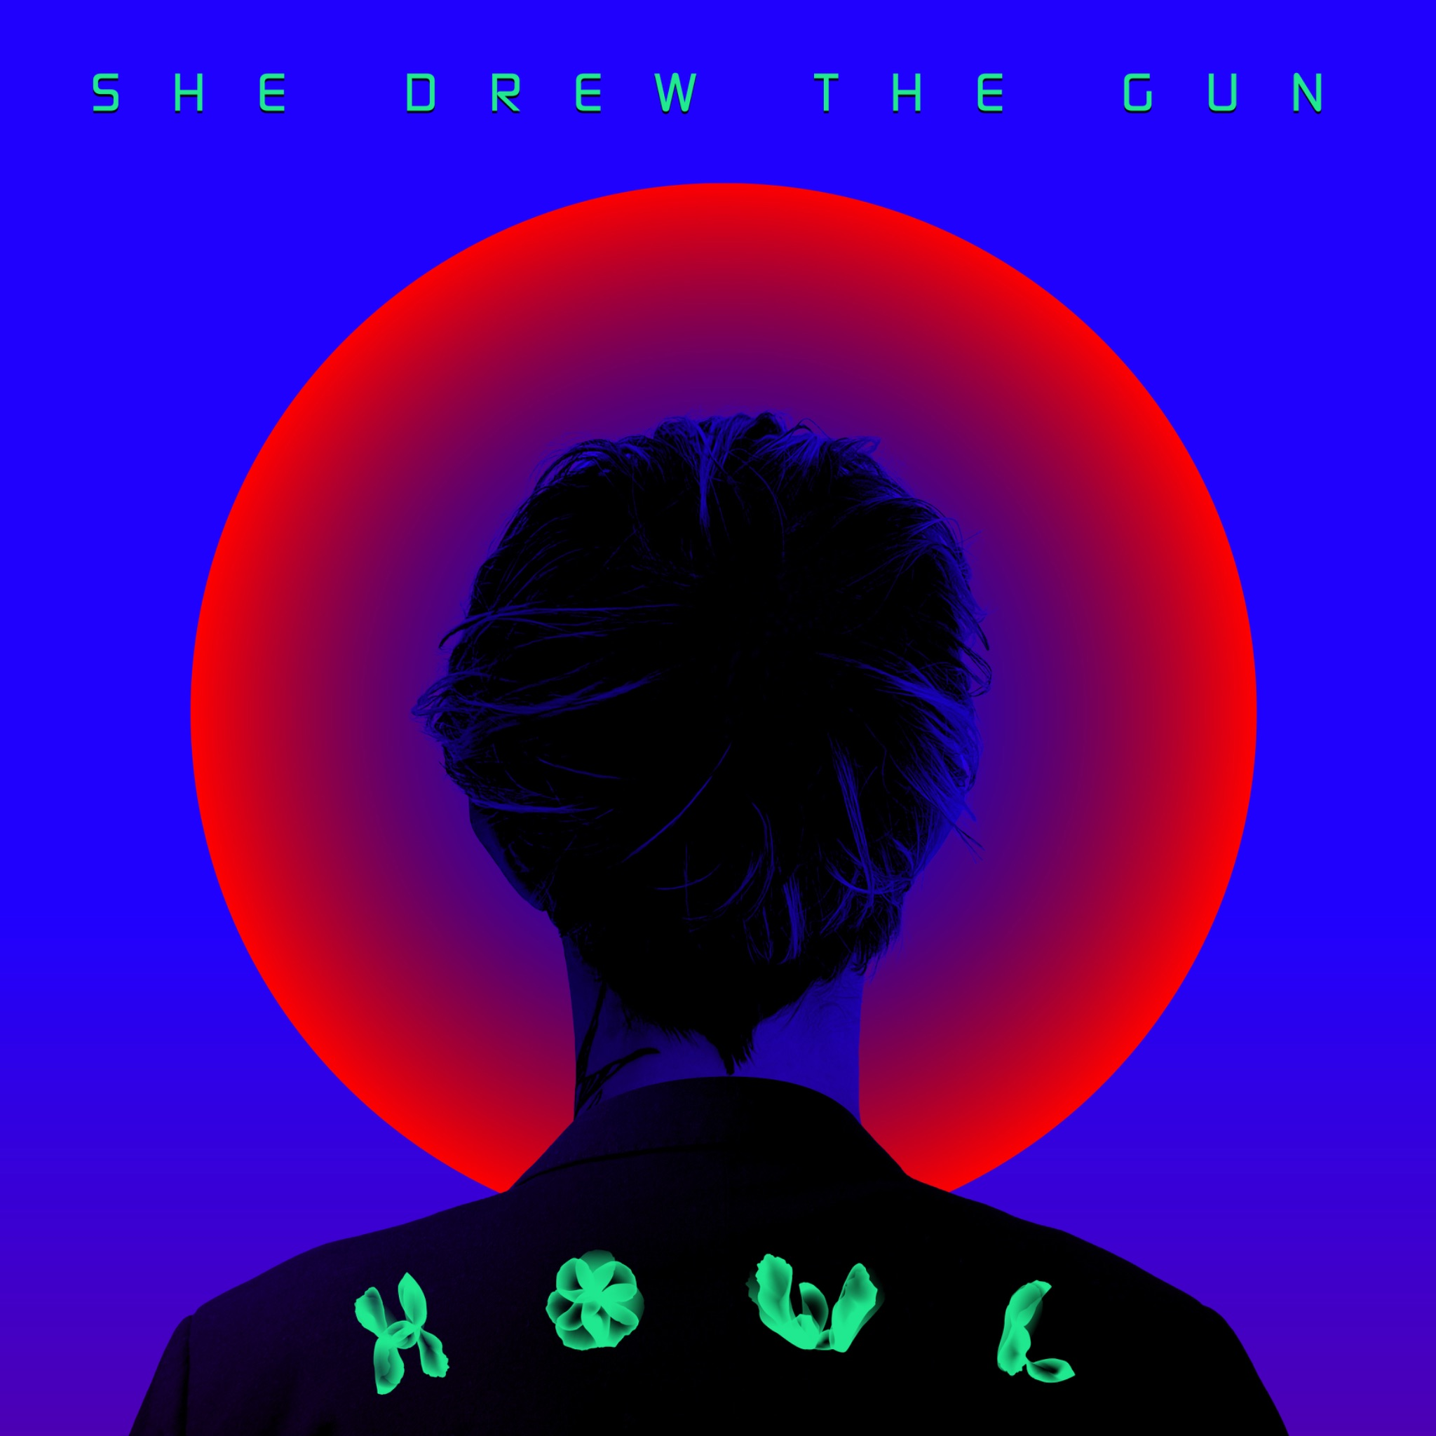
Download hi res artwork here

